Homework Assignment 1: Biography
Heather A Schumacker

Please type your responses and include a picture of yourself (that looks like you) in the box below. This is due the second day of class.
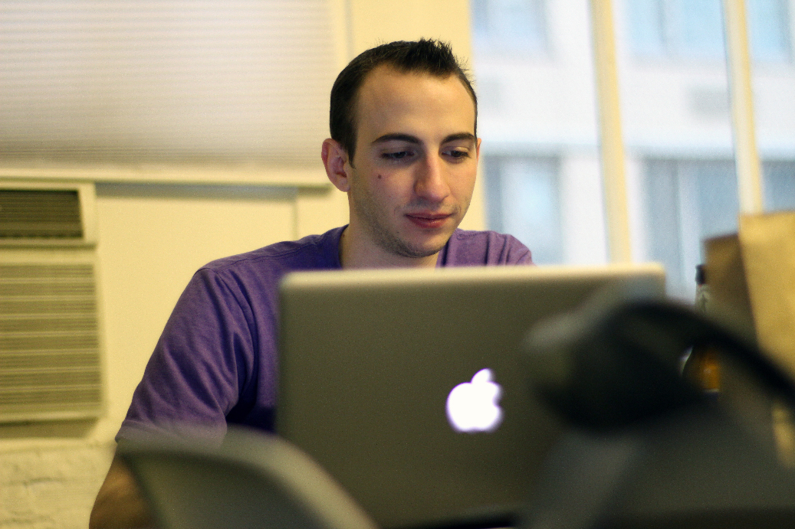
Your name as it appears on the role
Paul English

What you would like me to call you in class
Paul

Your email address
paul@onfrst.com

Why are you taking this class?
It seemed like an AI class I would most likely
enjoy, having taken both a pols & hist class before.

Have you taken any classes or do you have any experience (work, hobby, etc) in this subject area before, if so what?
I’ve had an American history (cp-slo) class in the past. I didn’t value it enough, and fell asleep too many times to really gain much from it. It was interesting all the same. I also had a intro political science class which I never fully prioritize over work. I didn’t finish the class, though I read through the book.

Is there anything that you are really wanting to learn from this class, if so what:
A greater understanding of the field of economics, outside of micro & macro. It will be interesting to see the progression of economic thoughts and ideas as it relates to the history of this nation. I have studied very little of economics outside of analyzing data I may have come across.

A little bit about who you are and something interesting or unique about yourself to help me remember who you are.
I’m a software developer, majoring in computer science. I like to study math for fun and regularly partake in hackathons (events where developers group up and compete or simply partake in the building of an app or piece of software in the course of an evening, day, or week), capture the flag competitions (events where hackers meet up and connect to sandboxed networks with virtual machines, attempting to both attack and/or sometimes defend computers from attacks), and machine learning competitions (usually on kaggle.com, data and statistics based modeling problems that real companies & institutions are facing and need to crowdsource to solve. Think Netflix prize or the Heritage Health prize) where I’m usually lucky if I even show up on a leader board. I write a blog mostly on math & computing related topics at nrub.onfrst.com, and share most of my non-commercial code at github.com/nrub.

